Windows 365 Tenant creation
Hi team you can use Demo windows 365 tenant to create lab for cloud PC. Make sure to check your account expires while performing lab in future.
- Create a demo tenant with an Windows 365 Enterprise license open below link and click on sign in.
Microsoft Customer Digital Experiences | My Environments
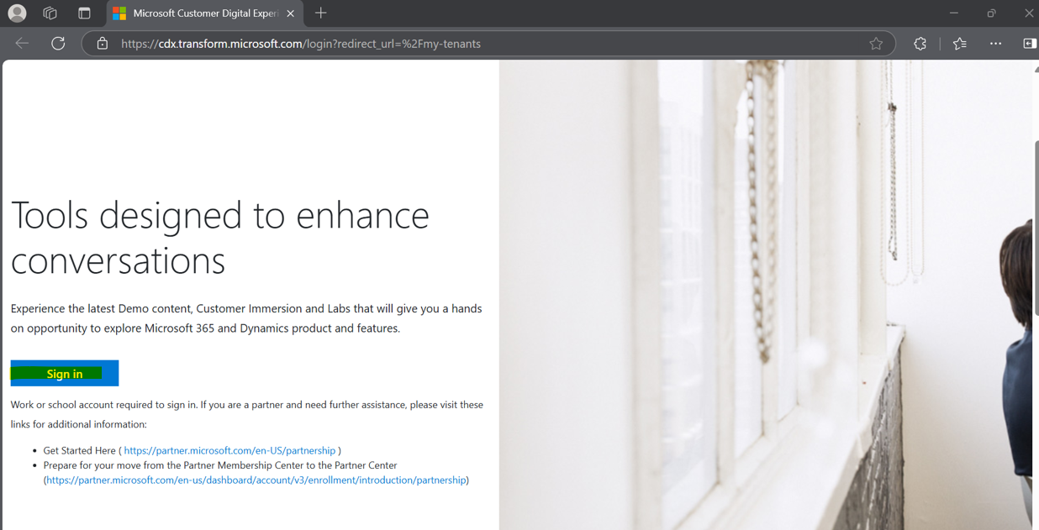
- Accept the policy and continue.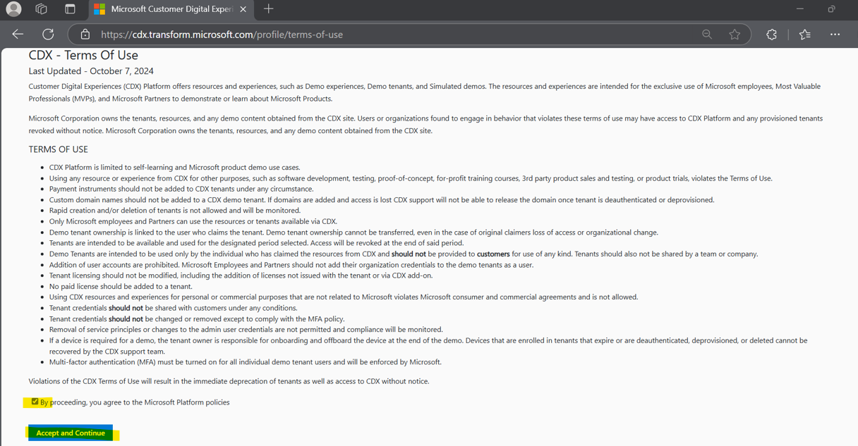
- Select the demo option
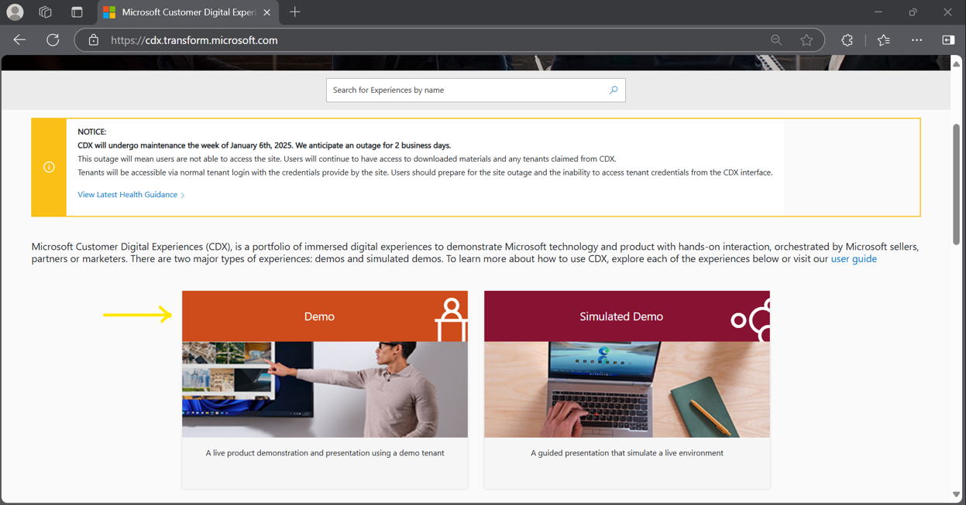

- click on My environment and create tenant option
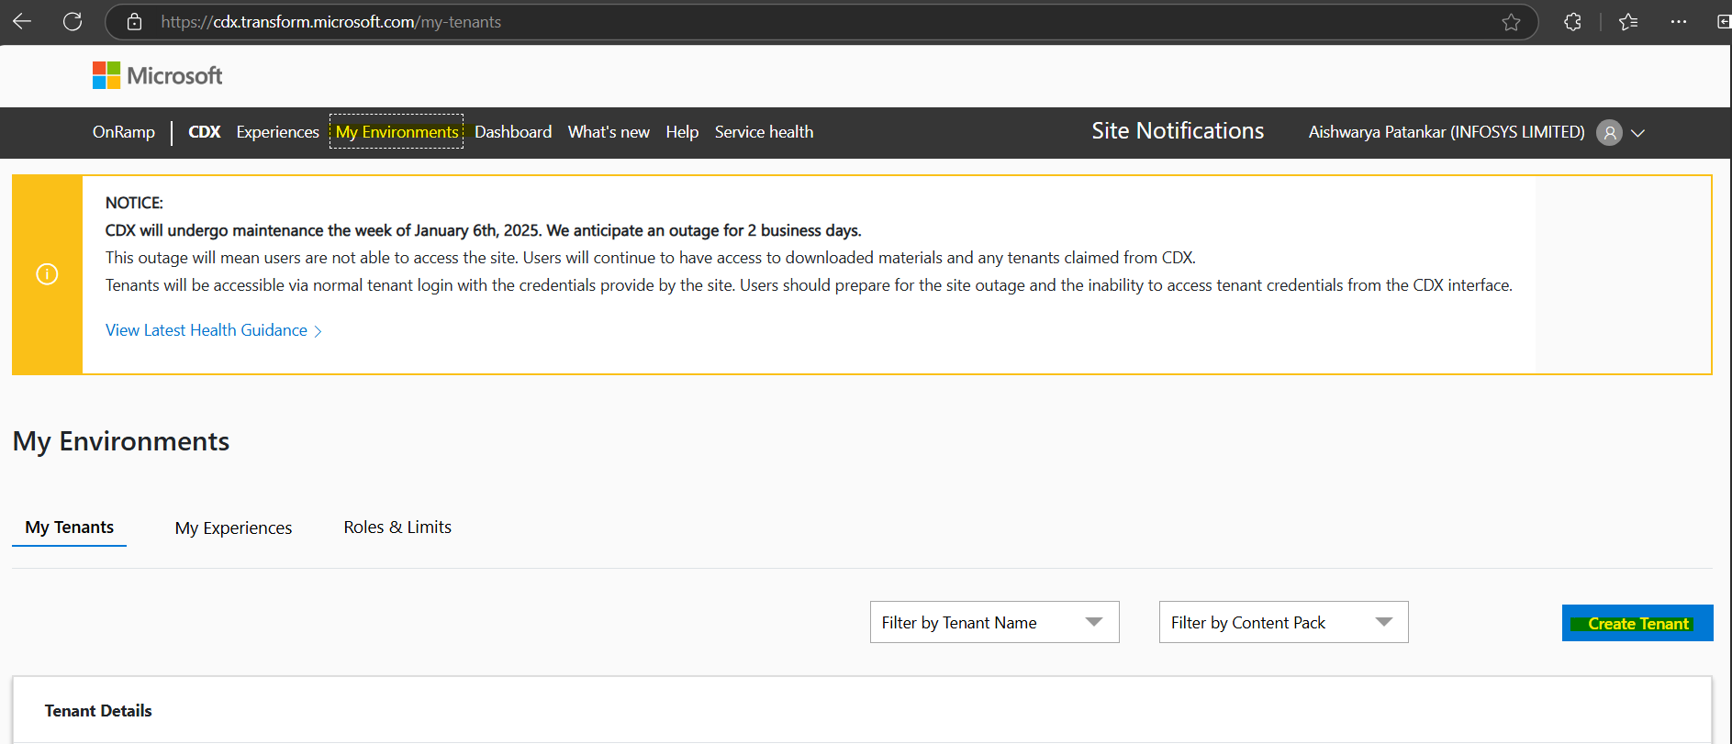
- Make sure *North America option is selected.
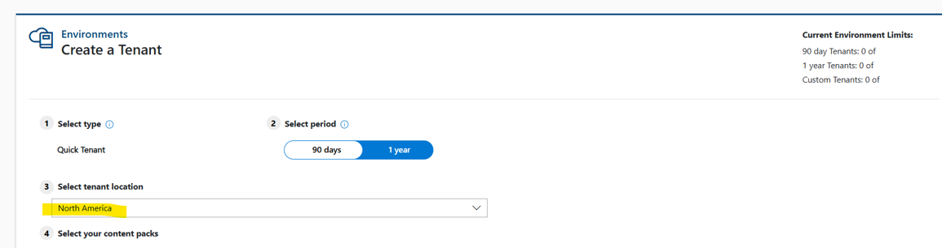

- Select the windows 365 demo tenant and create , accept policy.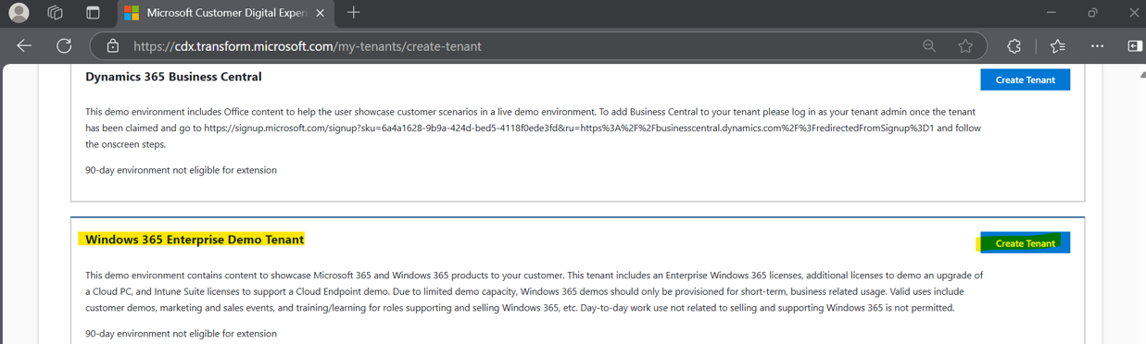
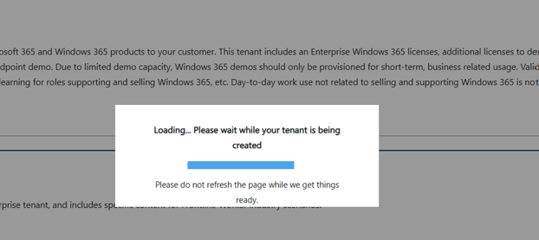
- Once tenant is created it will show page like below
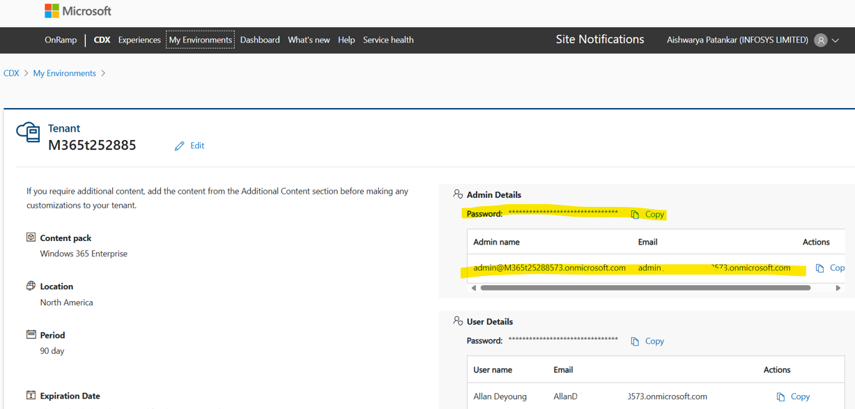
- Now try to login with new admin account on Intune portal .
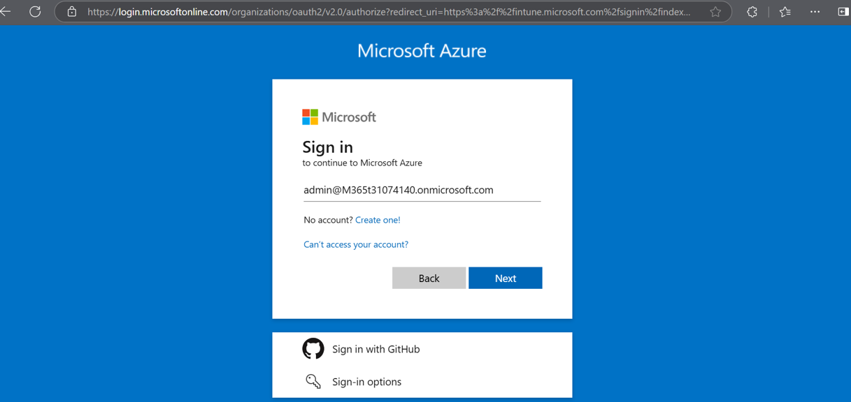
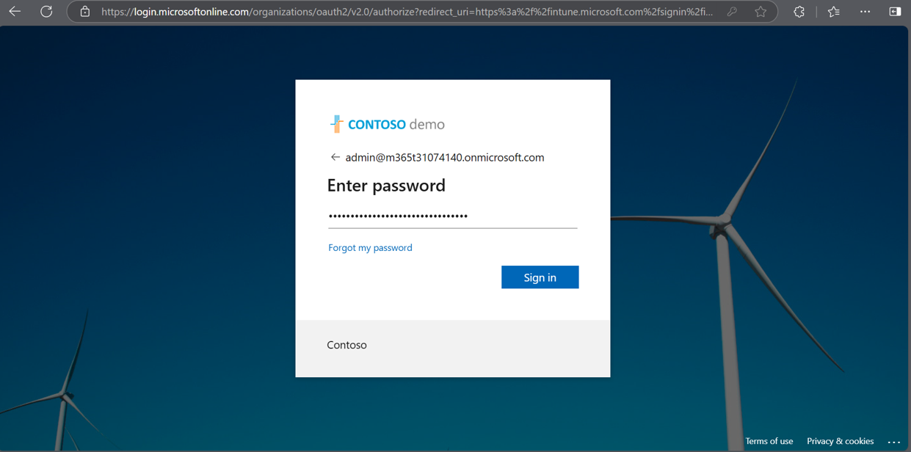
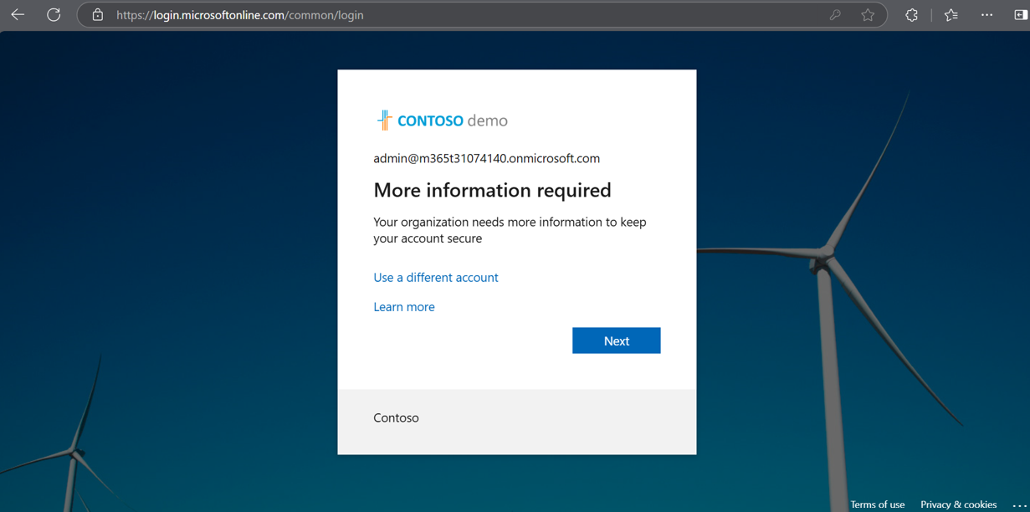
- Add the MFA authentication for the admin account.
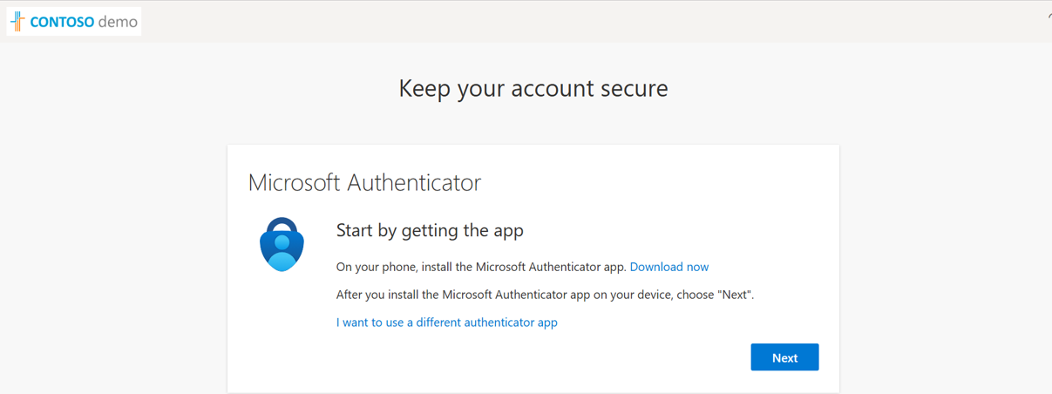
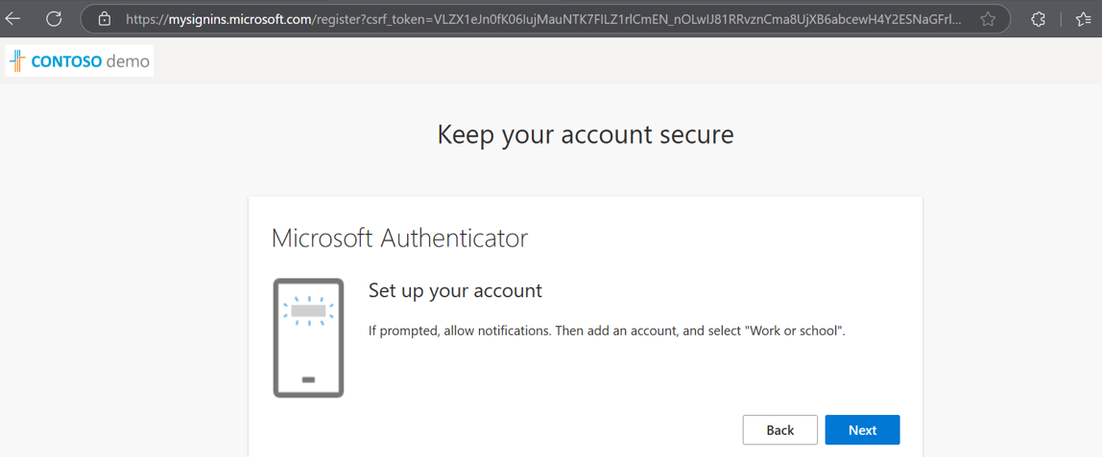
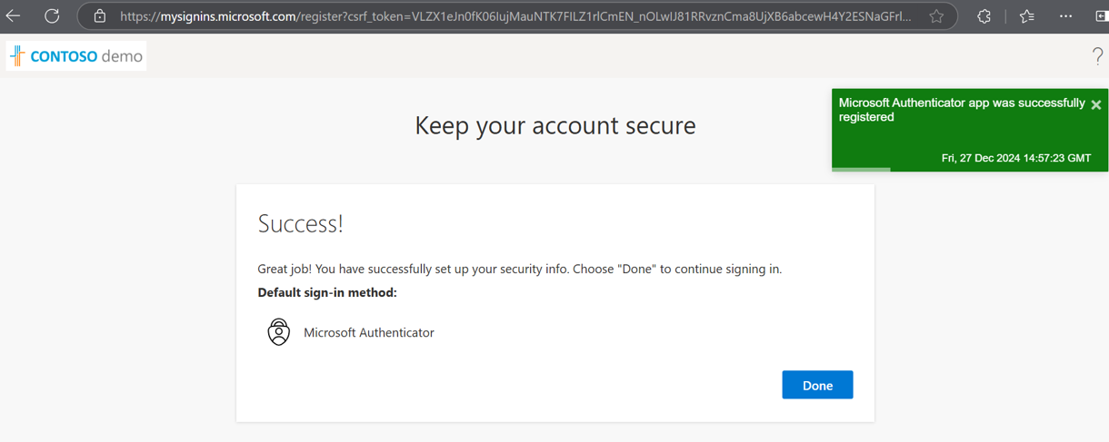

- We created the tenant successfully. Now you can perform your lab.
